
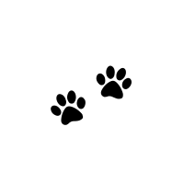
Smokey’s Detective Challenge
Use your detective skills to find something in the image below
- Something round
- Something spotted
- Something orange
- Something that flies
- Something warm
- Something red
